**Ganpat University**

**Faculty of Engineering & Technology**

**Computer Science & Engineering**

**Practical_2**

***Name:- Dwij Vatsal Desai***

***Sem:- 3***

***Sub: - DBMS­­***

***Enrollment No.:- 23162121027***

# Retrieving records from table

* 1. Find out the names of all clients.

Query: select name from client_master;

Image: 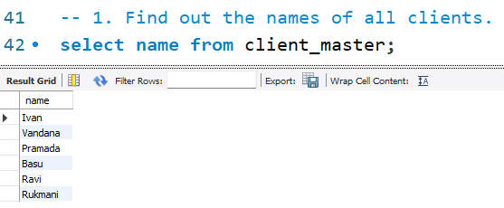

2) Retrieve the list of names and the cities of all the clients.

Query:

select name,City from client_master;

Image: 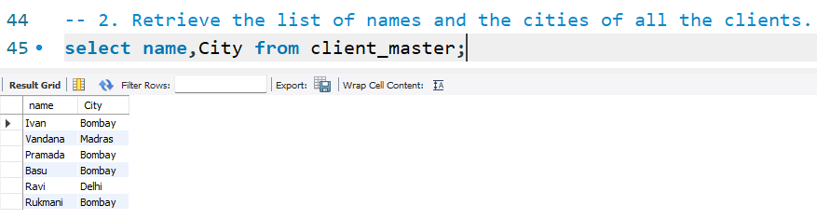

3. List the various products available from the product_master table.

Query:

select Description from product_master;

Image:

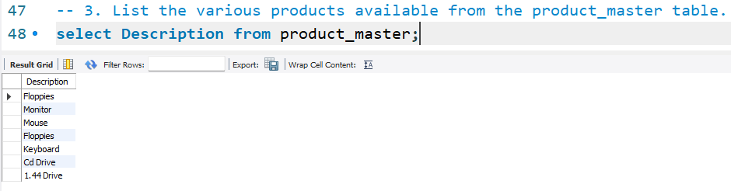

4) List all the clients who are located in Bombay.

Query:

select Name from client_master where City = 'Bombay';

Image:

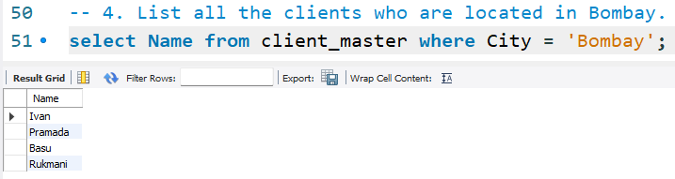

5) Find the names of the salesman who have a salary equal to Rs. 3000

Query:

select S_name from Salesman_master where Sal_Amt = 3000;

Image:

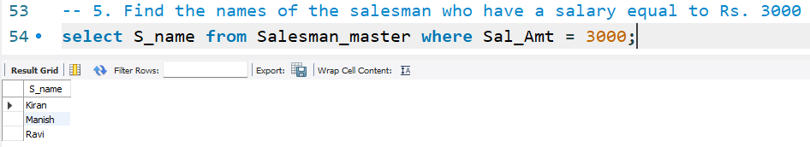

6. List out only unique values for the city of client_master table.

Query:

select distinct City from Salesman_master;

Image:

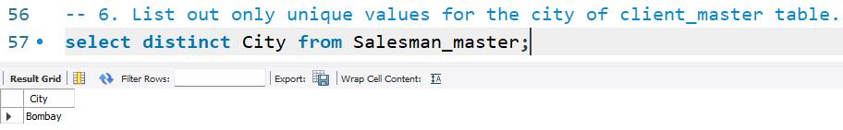

7) Display product_master table according to the sell_price of product.

Query:

select * from product_master order by sell_price;

Image:

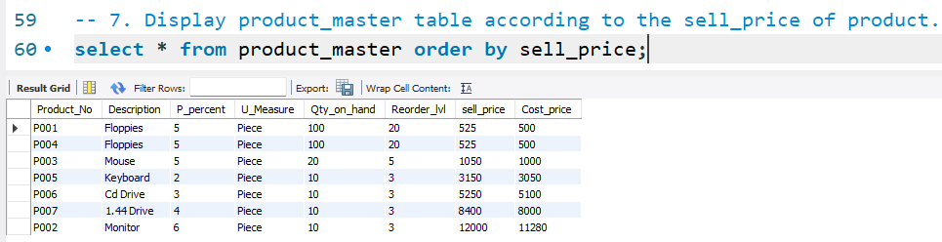

8) Display product_master table according to the sell_price and cost_price.

Query:

select * from product_master order by sell_price, cost_price;

Image:

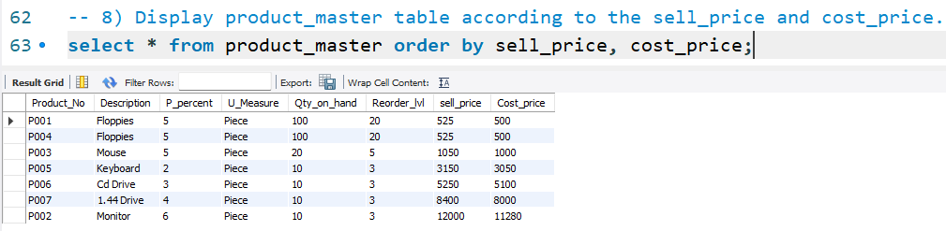

9) Display product_no, description in descending order of sell_price for product_master table.

Query:

select product_no, description, sell_price from product_master order by sell_price desc;

Image:

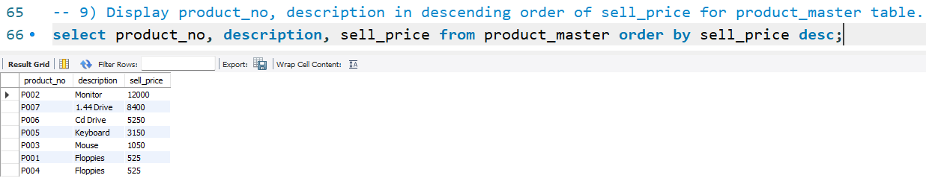

# Updating records in a table.

* 1. Change the city of client_no’C002’ to ‘Bombay’.

Query:

update client_master set city = 'Bombay' where client_no = 'C002';

select * from client_master;

Image:

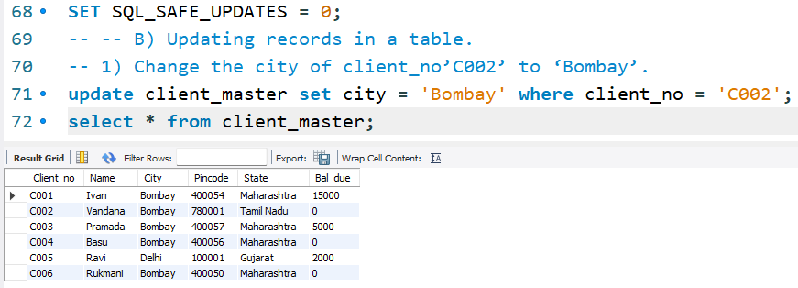

* 1. Change the bal_due of client_no’C001’ to Rs.1000

Query:

update client_master set Bal_due = 1000 where client_no = 'C001';

select * from client_master;

Image:

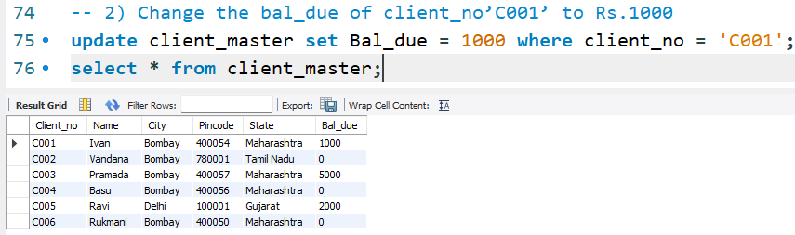

* 1. Change the cost price of Floppies to Rs. 950.00

Query:

update Product_master set Cost_price = 950 where Description = 'Floppies';

select * from Product_master;

Image:

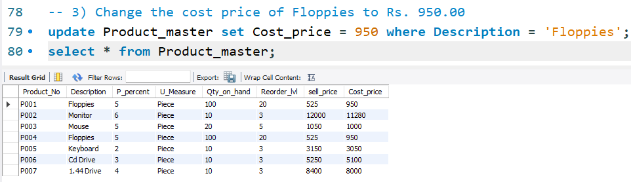

* 1. Change the city of the salesman to Mumbai.

Query:

update Salesman_master set City='Mumbai';

select * from Salesman_master;

Image:

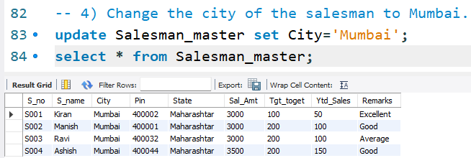

# Deleting records in a table:

* 1. Delete all salesman from the salesmane_master whose salaries are equal to Rs. 3500.

Query:

delete from Salesman_master where sal_amt = 3500;

select * from Salesman_master;

Image: 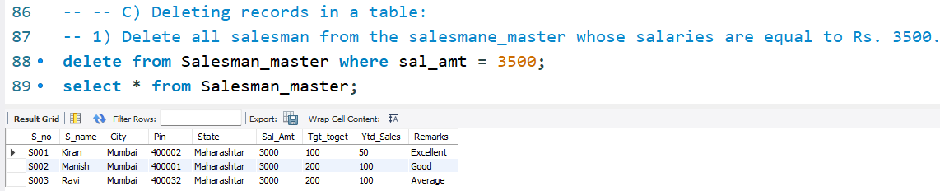

* 1. Delete all products from product_master where the quantity on hand is equal to 100.

Query:

delete from Product_master where Qty_on_hand = 100;

select * from Product_master;

Image: 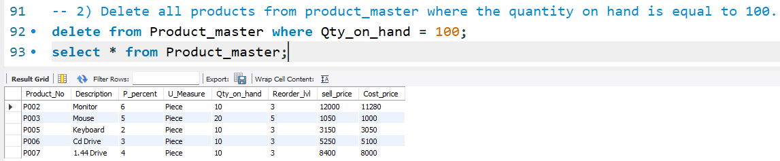

* 1. Delete from client_master where the column state holds the value ‘Tamil Nadu’.

Query:

delete from client_master where State = 'Tamil Nadu';

select * from client_master;

Image: 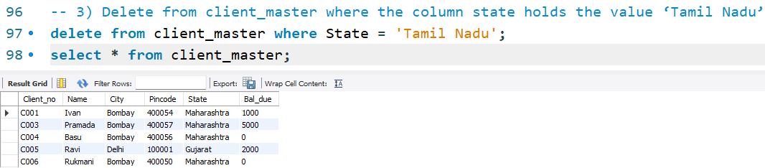

# Altering the table structure:

* 1. Add a column called ‘telephone’ of datatype ‘number’ and size=10 to the client_master table.

Query:

alter table client_master add column telephone numeric(10);

select * from client_master;

Image: 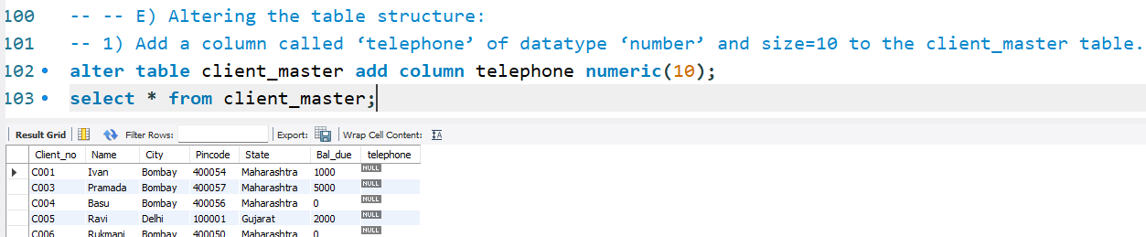

* 1. Change the size of sell_price column in product_master to 10,2.

Query:

alter table product_master modify column sell_price decimal(10,2);

select * from product_master;

Image: 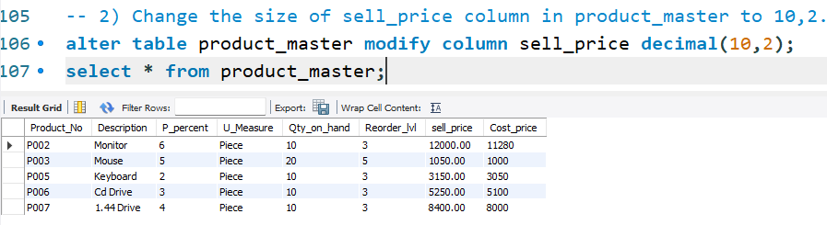

* 1. Rename column telephone to new name as contact for client_master table.

Query:

alter table client_master modify column telephone numeric(10);

select * from client_master;

Image: 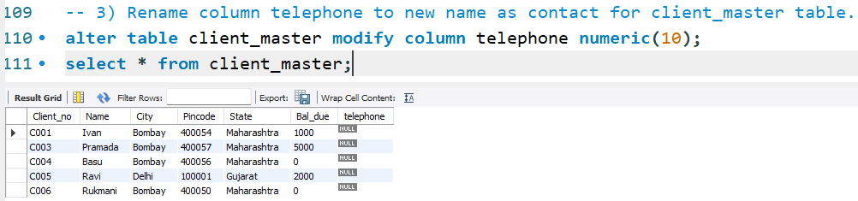

* 1. Delete column contact from client_master table.

Query:

alter table client_master drop Pincode;

select * from client_master;

Image: 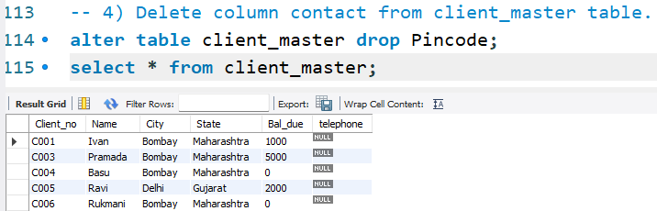

# Deleting the table structure along with data:

Create table employee with 4 columns and 5 rows.

* 1. Destroy the table employee along with its data.

Query:

alter table client_master drop Pincode;

select * from client_master;

Image: 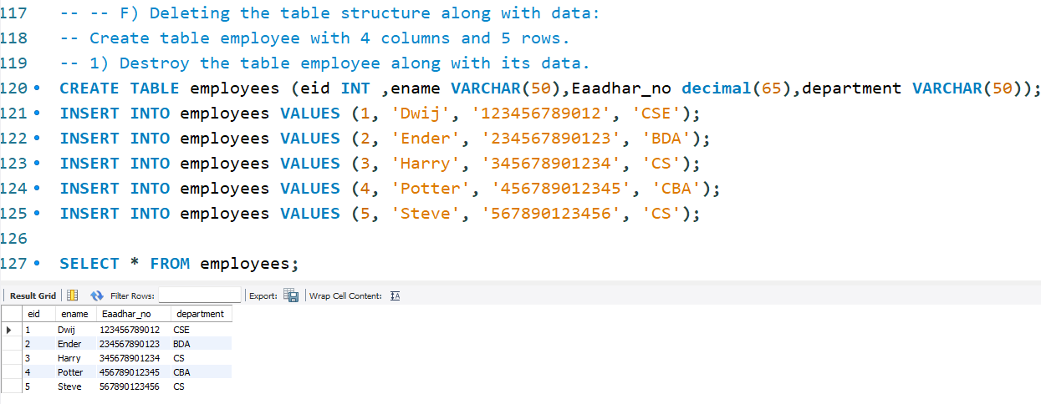

(droping the employees table)



# Renaming the table:

* 1. Change the name of the salesman_master table to sman_mast.

Query:

rename table salesman_master to sman_mast;

SELECT * FROM sman_mast;

Image: 